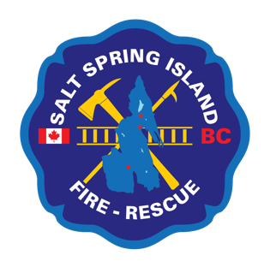
Salt Spring Island Fire Rescue
Fire Chief’s Report
March 2016

Response Report
March 2015 has been one of our lowest call volume month’s in the past five years with 35 incidents. At month end (March 2016) SSIFR had responded to 119 incidents.


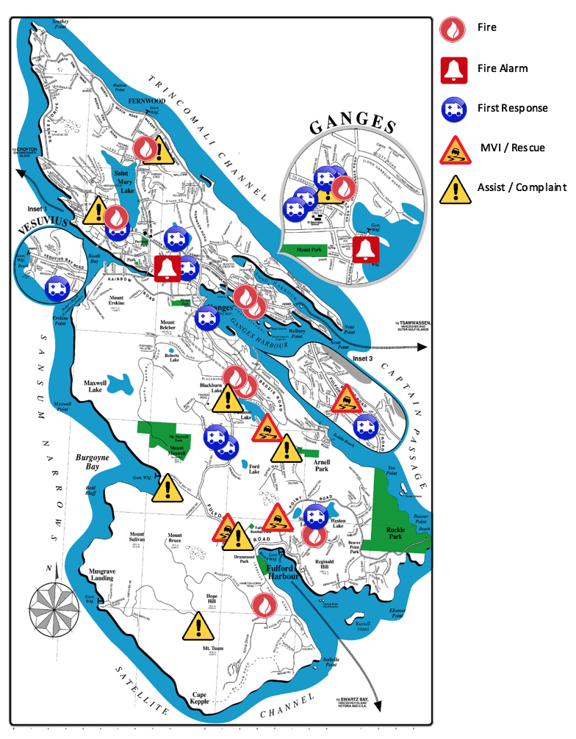
Operations Update
The new updated call map includes a new icon for Fire Alarms.
This icon will represent a commercial or a residential fire alarm activation. Fire Alarms can be activated intentionally or accidentally. SSIFR responds to all alarms as a “fire” until it can be confirmed a false alarm.

Membership

Our current membership as of March 2016 is 41 members. We have two members on a leave of absence (LOA). Both LOA’s are for personal leaves, one three months, and one for six months. We hope to see both of them back soon. Also as of April 1st we welcome back one of our members who was on a 3-month personal leave of absence.
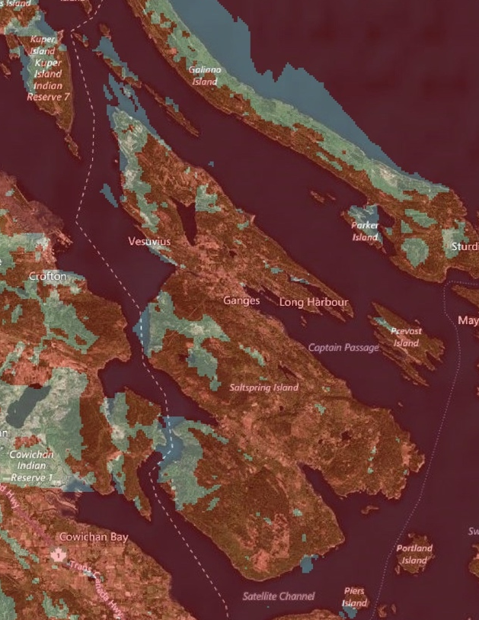
At a recent Fire Service Leadership meeting in Langford, we received some new information regarding the CREST radio system that we currently use. CREST stands for Capital Region Emergency Services Telecommunications. The system we are using is going to be replaced by a new P25 digital system by 2018. There are no exact budget details or costing available yet, but should be available in the near future. The new system will require all new portable radios, new mobile radios, new repeaters, and new pagers. The system will also provide Salt Spring Island with better digital radio and pager coverage.
Below is a map of the current pager/ radio coverage. The west side of Salt Spring Island is shaded as poor, and the new digital system should help in these areas. I would recommend that we begin the radio/pager switch over as early as possible so we are trained and prepared come 2018. I will present budget figures as soon as possible and available from CREST.
The other main topic of discussion at the Fire Service Leadership meeting was the BC OFC Playbook. The departments that were represented at the meeting concentrated on record keeping and documentation.
As a follow-up to the February Trustee meeting, here is a list of departments and the reasoning why they selected the service level they did. Most Fire Chief’s I talked to, had the municipality follow the Chief’s recommendations, and one other increased the level from which the Fire Chief recommended.
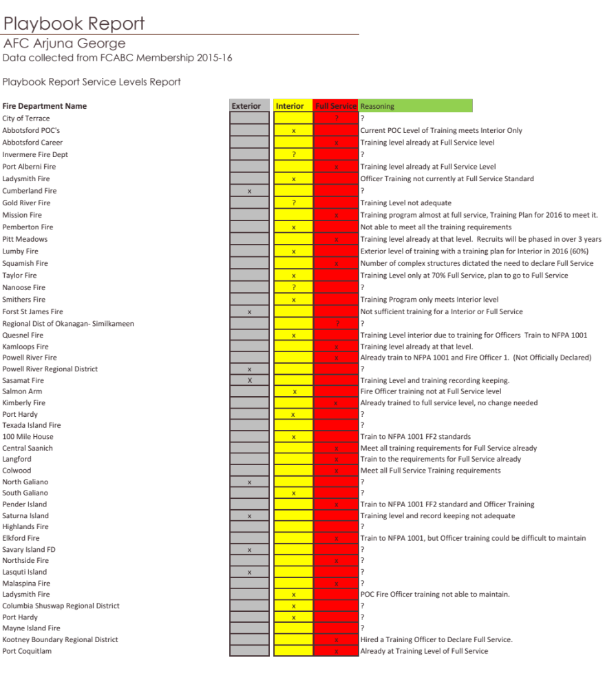The “?” refers to FD’s that are in the process, but have not officially declared or no reasoning was provided.
Here is a snapshot of the Fire Departments that have declared or are the final process of declaring.

Training Division
Six junior members successfully passed the Code 3 Driver training course (SOFA) in Victoria. This course is one of the final requirements to be eligible to operate a SSIFR apparatus Code 3. To become a Code 3 Driver firefighters are required to complete the in-house training, Air Brakes, Code 3 Driver, pumps and pumping, and a final driving test with SSIFR evaluators.
Three of our Officers had a chance to listen to former Saskatchewan Fire Chief Les Karpluck in Errington BC on Fire Service Leadership. Upon returning the three Officers shared their experiences and nuggets of leadership with the rest of our Officership. The topic of leading different generations really hit home for our Officers and brewed great discussion on the future of Recruitment and Retention.
We have been training with Ground Search and Rescue (GSAR) for a while in regards to technical rope rescue, but we have recently extended the partnership to include our First Responder training. Working with GSAR has proven to be beneficial for both agencies.
Inspection and Public Education Division
For the month of March eighteen (18) Fire and Life Safety Inspections were completed along with one (1) subdivision review. Our Public Education team conducted a First Aid, Fire Extinguisher and kitchen safety workshop for 30 GISS cafeteria students. We also had six (6) Fire Hall tours, learning the ins and outs of our Fire Trucks, equipment and fire safety information. Planning and organizing has also begun for the annual P.A.R.T.Y program event held in conjunction with VIHA, BCAS, RCMP, and Lady Minto Hospital.
Upcoming Events
- April 24th junior members will be attending the Code Three driving course (SOFA) in Victoria
- April 24th junior members will be taking the HAZMAT awareness level course on-island instructed by our in-house instructors.
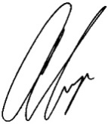
Respectfully Submitted

Arjuna George, Acting Fire Chief

